Experiment 08

**Aim:**

To Study Project Scheduling Using Gantt chart in ClickUp.

**Theory:**

Project Scheduling-

A project schedule is a timeline that outlines the tasks, milestones, deadlines, and resources required for completing a project. It helps project managers organise and plan the sequence of activities, allocate resources efficiently, set realistic timelines, and monitor progress. Having a clear project schedule is crucial for a project manager as it ensures tasks are completed on time, helps in managing resources effectively, allows for better coordination among team members, and assists in identifying potential issues or delays, enabling timely adjustments to keep the project on track.

Gantt chart-

A Gantt chart, commonly used in project management, is one of the most popular and useful ways of showing activities (tasks or events) displayed against time. On the left of the chart is a list of the activities and along the top is a suitable time scale. Each activity is represented by a bar; the position and length of the bar reflects the start date, duration and end date of the activity.

About the topic-

It is a Logistic regression Model designed on Agricultural decision making based on soil characteristics and various other environmental factors. Our dataset Encompasses of essential parameters such as soil composition (Nitrogen,potassium and phosphorus contents of the soil as well as the pH level of the soil) and location specific variables such as temperature, humidity and rainfall. Our model leverages these inputs and aims to predicts the most suitable crop for a given soil and environmental conditions.

**Output**:

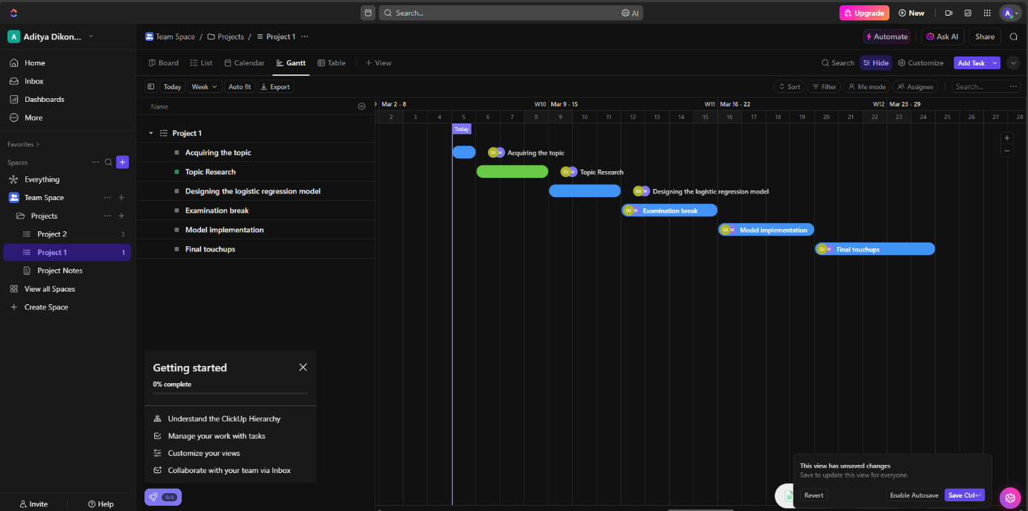

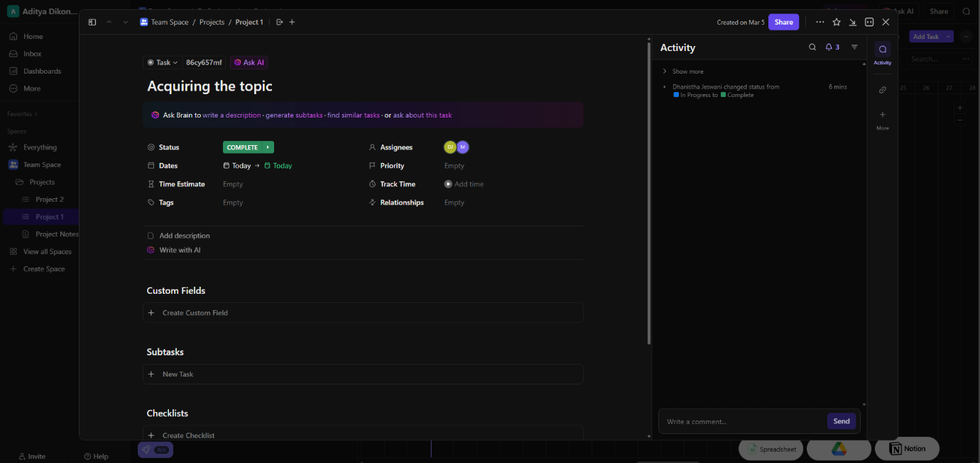

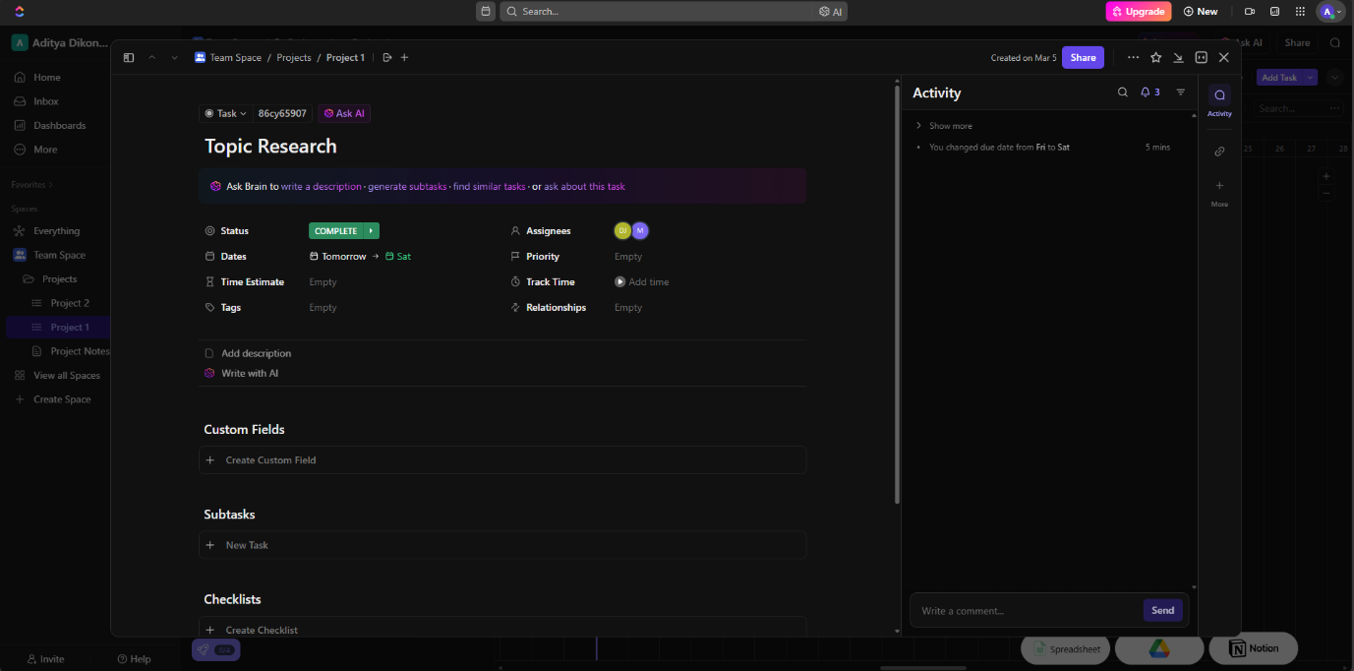

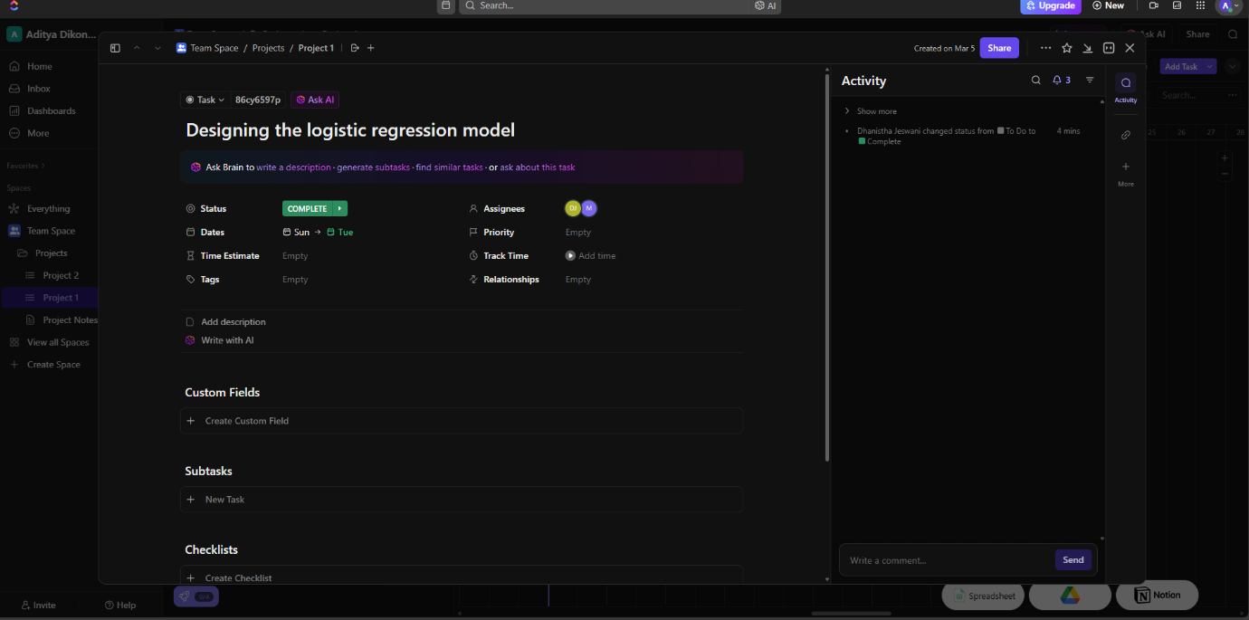

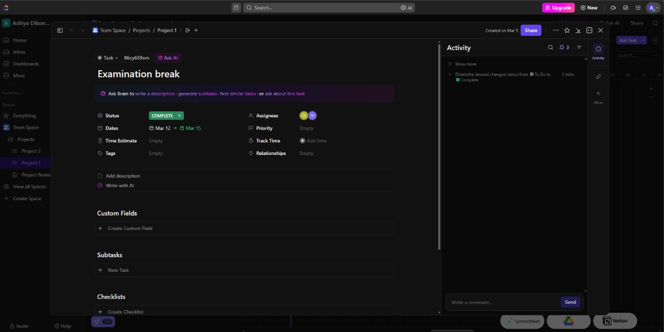

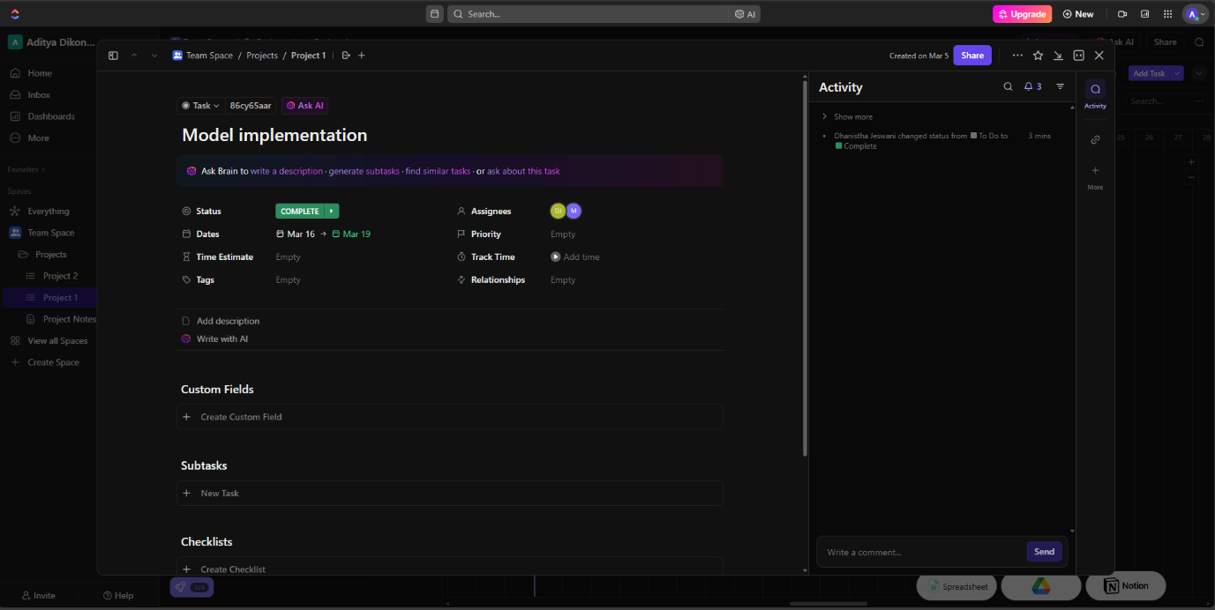

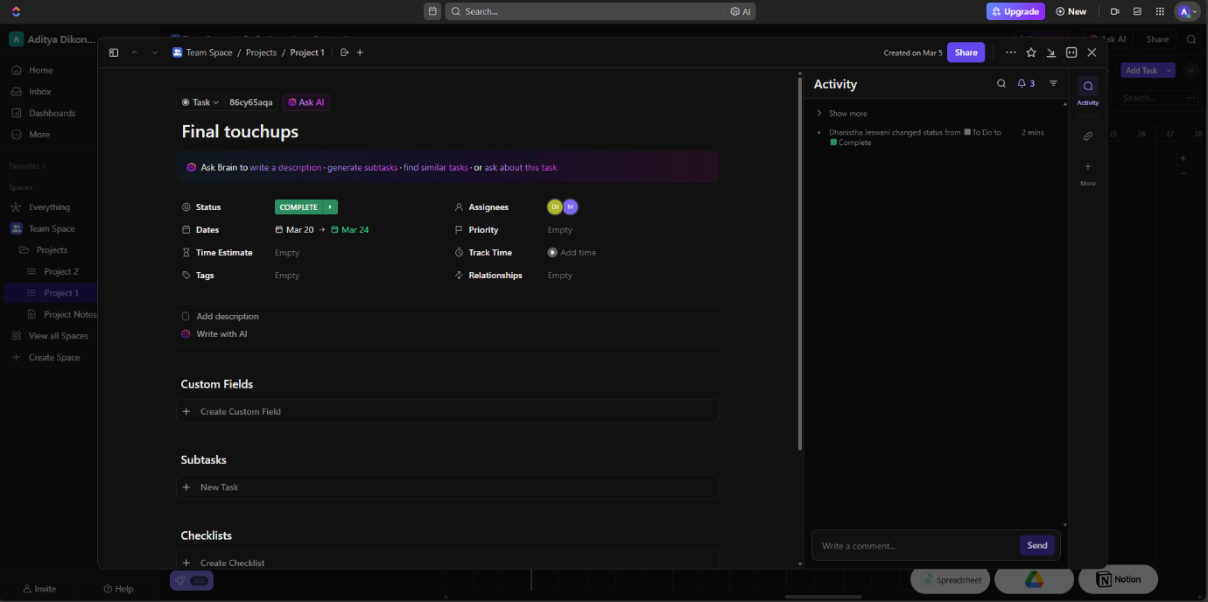

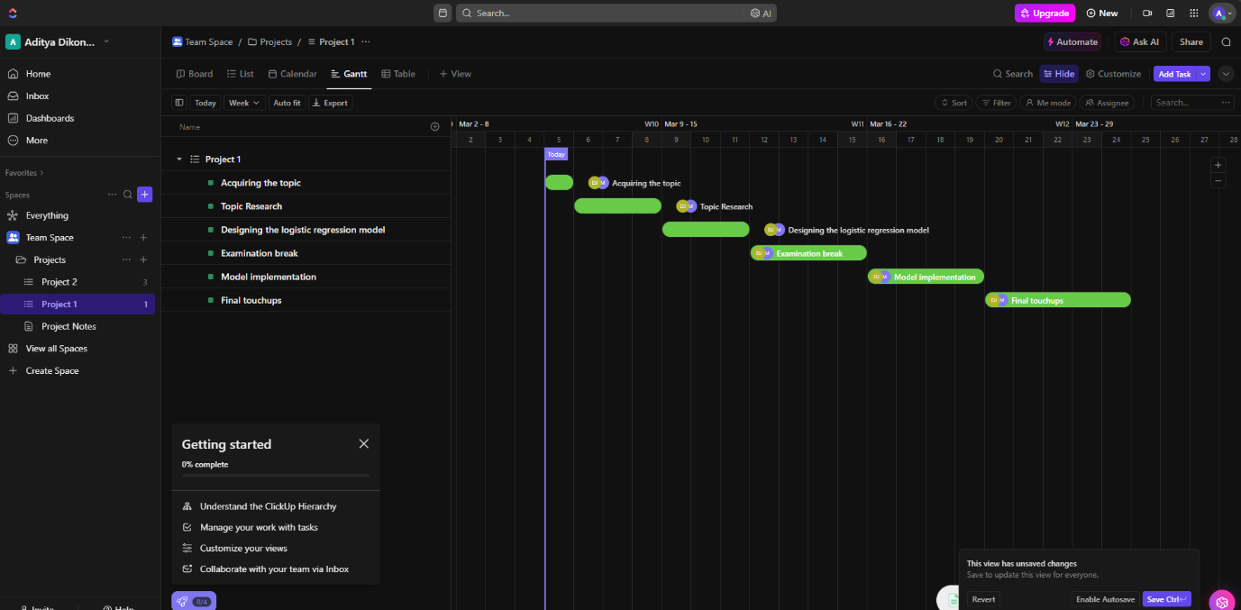

**Conclusion**:

This project delved into the application of polynomial regression in financial data analysis, comparing implementations from scratch using Python libraries with those utilizing PyTorch. Through data preprocessing, model implementation, training, and evaluation, we examined the performance of each approach. While both methods proved effective, PyTorch demonstrated advantages in computational efficiency and scalability. This project underscores the importance of selecting appropriate tools and frameworks based on the task's requirements, offering insights into the practical utility of polynomial regression in financial modeling.